Cloud Application Migration

🌟 Definition
# Source: AI Source: Provided by: [Data Path: Persons Table -> ID Column: 1, Name_En Column: Motasem Essam] -> From: [ChatGPT] on [6/7/2026]
Cloud Application Migration is the process of moving an application from an on-premises environment, local server, or data center to a cloud platform.
The migration may include:
- Application code
- Databases
- Files
- APIs
- Configurations
- Infrastructure

🎯 Purpose
# Source: AI Source: Provided by: [Data Path: Persons Table -> ID Column: 1, Name_En Column: Motasem Essam] -> From: [ChatGPT] on [6/7/2026]
Cloud application migration is performed to:
- Improve scalability
- Reduce infrastructure costs
- Increase availability
- Simplify maintenance
- Improve disaster recovery
- Support global users

🧠 Simple Definition
# Source: AI Source: Provided by: [Data Path: Persons Table -> ID Column: 1, Name_En Column: Motasem Essam] -> From: [ChatGPT] on [6/7/2026]
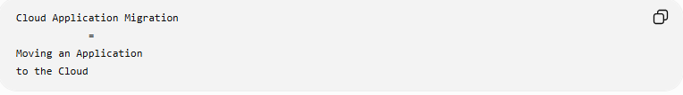
Cloud Application Migration
=
Moving an Application
to the Cloud

📚 What Gets Migrated?
# Source: AI Source: Provided by: [Data Path: Persons Table -> ID Column: 1, Name_En Column: Motasem Essam] -> From: [ChatGPT] on [6/7/2026]
A typical application contains:
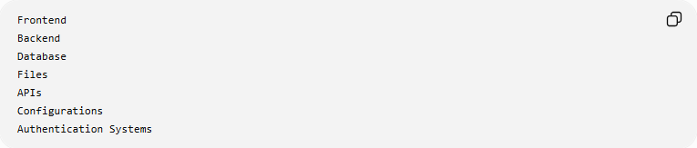
Frontend
Backend
Database
Files
APIs
Configurations
Authentication Systems
All or some of these components may be migrated.

🏢 Before Cloud Migration
# Source: AI Source: Provided by: [Data Path: Persons Table -> ID Column: 1, Name_En Column: Motasem Essam] -> From: [ChatGPT] on [6/7/2026]
Traditional setup:
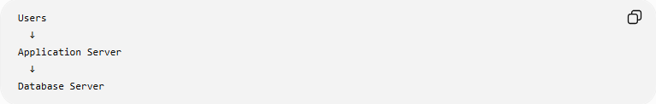
Users
↓
Application Server
↓
Database Server
Located inside:
Company Office
Data Center

Problems:
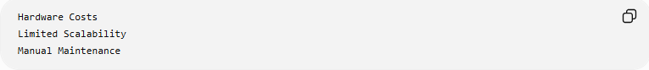
Hardware Costs
Limited Scalability
Manual Maintenance

☁️ After Cloud Migration
# Source: AI Source: Provided by: [Data Path: Persons Table -> ID Column: 1, Name_En Column: Motasem Essam] -> From: [ChatGPT] on [6/7/2026]
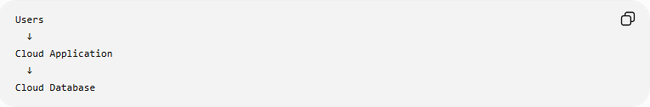
Users
↓
Cloud Application
↓
Cloud Database
Hosted on a cloud platform.

🔍 Common Cloud Migration Scenarios

1️⃣ On-Premises to Cloud
# Source: AI Source: Provided by: [Data Path: Persons Table -> ID Column: 1, Name_En Column: Motasem Essam] -> From: [ChatGPT] on [6/7/2026]
Before
Company Data Center

After
Cloud Platform

Example:
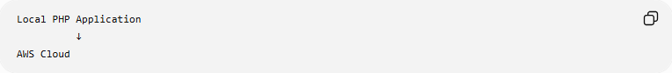
Local PHP Application
↓
AWS Cloud

2️⃣ Cloud-to-Cloud Migration
# Source: AI Source: Provided by: [Data Path: Persons Table -> ID Column: 1, Name_En Column: Motasem Essam] -> From: [ChatGPT] on [6/7/2026]
Move between cloud providers.
Example
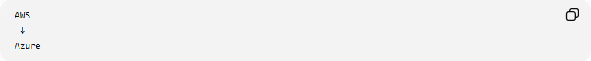
AWS
↓
Azure
or
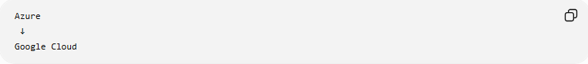
Azure
↓
Google Cloud

Reasons:
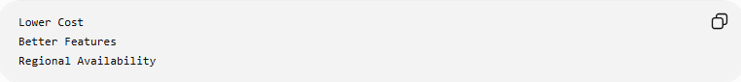
Lower Cost
Better Features
Regional Availability

3️⃣ Hybrid Cloud Migration
# Source: AI Source: Provided by: [Data Path: Persons Table -> ID Column: 1, Name_En Column: Motasem Essam] -> From: [ChatGPT] on [6/7/2026]
Part remains local, part moves to the cloud.
Example
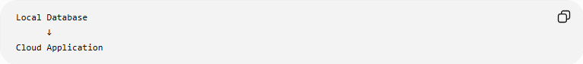
Local Database
↓
Cloud Application

or
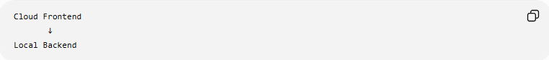
Cloud Frontend
↓
Local Backend

☁️ Popular Cloud Platforms
# Source: AI Source: Provided by: [Data Path: Persons Table -> ID Column: 1, Name_En Column: Motasem Essam] -> From: [ChatGPT] on [6/7/2026]
Common cloud providers:
- Amazon Web Services
- Microsoft
- Google

🛠️ Real-World Example
# Source: AI Source: Provided by: [Data Path: Persons Table -> ID Column: 1, Name_En Column: Motasem Essam] -> From: [ChatGPT] on [6/7/2026]
Before Migration
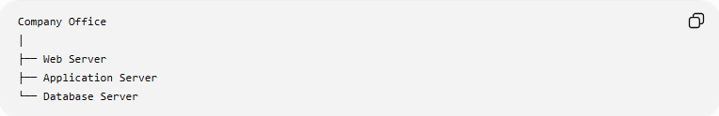
Company Office
│
├── Web Server
├── Application Server
└── Database Server

Problems:
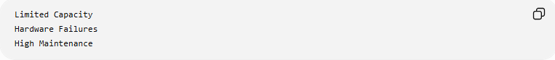
Limited Capacity
Hardware Failures
High Maintenance

Migration
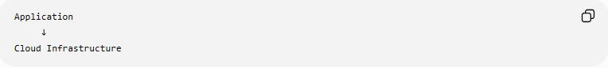
Application
↓
Cloud Infrastructure

After Migration
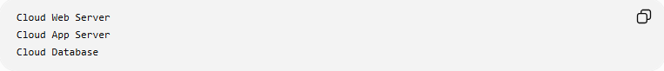
Cloud Web Server
Cloud App Server
Cloud Database

Benefits:
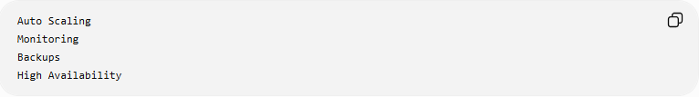
Auto Scaling
Monitoring
Backups
High Availability

🔄 Cloud Application Migration Lifecycle
# Source: AI Source: Provided by: [Data Path: Persons Table -> ID Column: 1, Name_En Column: Motasem Essam] -> From: [ChatGPT] on [6/7/2026]
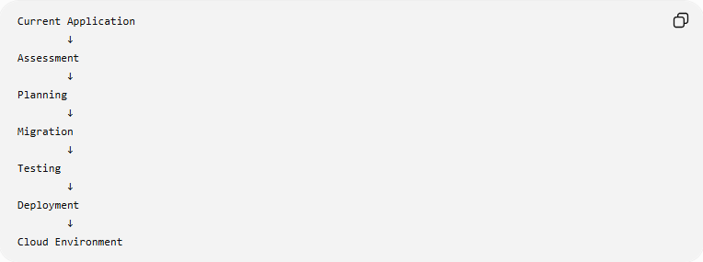
Current Application
↓
Assessment
↓
Planning
↓
Migration
↓
Testing
↓
Deployment
↓
Cloud Environment

📦 Cloud Migration Strategies (The 6 Rs)
# Source: AI Source: Provided by: [Data Path: Persons Table -> ID Column: 1, Name_En Column: Motasem Essam] -> From: [ChatGPT] on [6/7/2026]
1. Rehost (Lift and Shift)
Move application without major changes.
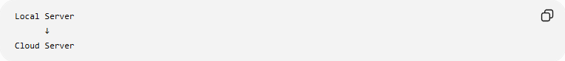
Local Server
↓
Cloud Server
Fastest approach.

2. Replatform
Make small improvements during migration.
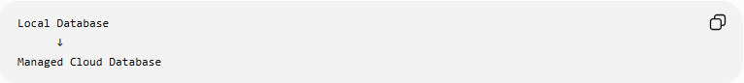
Local Database
↓
Managed Cloud Database

3. Refactor / Re-Architect
Redesign the application.
Example
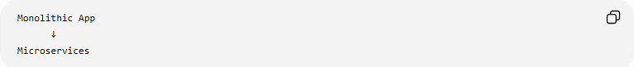
Monolithic App
↓
Microservices

4. Repurchase
Replace the application with a cloud service.
Example
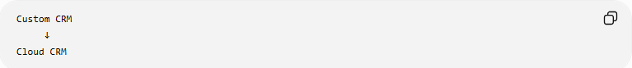
Custom CRM
↓
Cloud CRM

5. Retire
Remove unused applications.
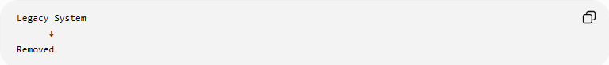
Legacy System
↓
Removed

6. Retain
Keep the application unchanged.
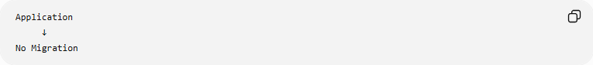
Application
↓
No Migration

🔧 Components Commonly Migrated
# Source: AI Source: Provided by: [Data Path: Persons Table -> ID Column: 1, Name_En Column: Motasem Essam] -> From: [ChatGPT] on [6/7/2026]
Application Code
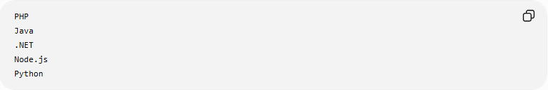
PHP
Java
.NET
Node.js
Python

Databases
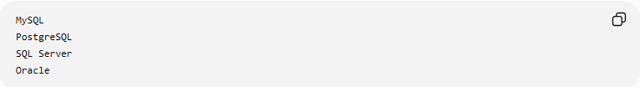
MySQL
PostgreSQL
SQL Server
Oracle

Files
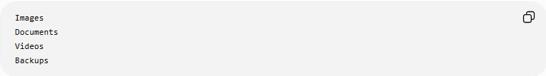
Images
Documents
Videos
Backups

APIs
Internal APIs
External APIs

🌍 Example Architecture
# Source: AI Source: Provided by: [Data Path: Persons Table -> ID Column: 1, Name_En Column: Motasem Essam] -> From: [ChatGPT] on [6/7/2026]
Before
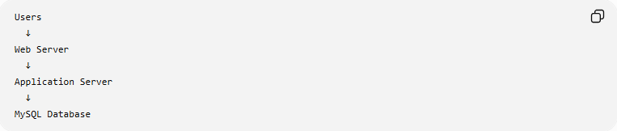
Users
↓
Web Server
↓
Application Server
↓
MySQL Database

After
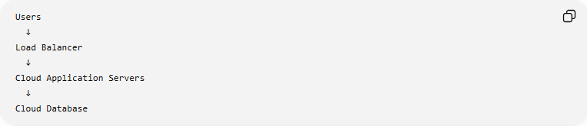
Users
↓
Load Balancer
↓
Cloud Application Servers
↓
Cloud Database

⚠️ Common Challenges
# Source: AI Source: Provided by: [Data Path: Persons Table -> ID Column: 1, Name_En Column: Motasem Essam] -> From: [ChatGPT] on [6/7/2026]
Downtime
Migration may require maintenance windows.

Data Transfer Size
Large applications may contain:
Millions of Records
Terabytes of Files

Security
Sensitive data must remain protected.

Compatibility Issues
Applications may depend on:
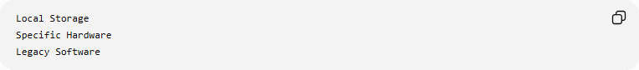
Local Storage
Specific Hardware
Legacy Software

Cost Management
Cloud resources must be monitored carefully.

✅ Benefits
# Source: AI Source: Provided by: [Data Path: Persons Table -> ID Column: 1, Name_En Column: Motasem Essam] -> From: [ChatGPT] on [6/7/2026]
Scalability
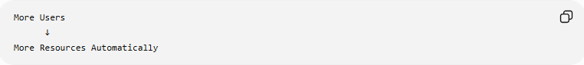
More Users
↓
More Resources Automatically

High Availability
Automatic Failover

Global Access
Users Worldwide

Disaster Recovery
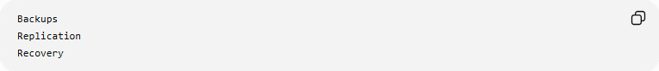
Backups
Replication
Recovery

Reduced Maintenance
Cloud provider manages:
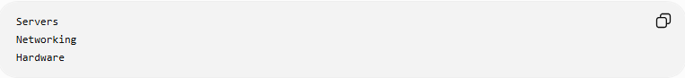
Servers
Networking
Hardware

📊 Cloud Application Migration vs Cloud Database Migration
# Source: AI Source: Provided by: [Data Path: Persons Table -> ID Column: 1, Name_En Column: Motasem Essam] -> From: [ChatGPT] on [6/7/2026]
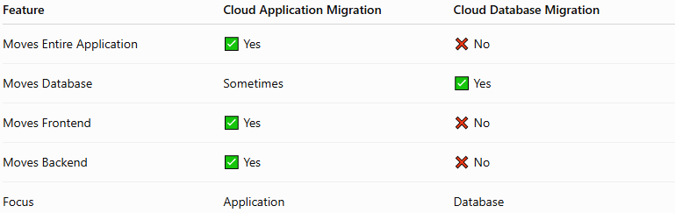
Feature | Cloud Application Migration | Cloud Database Migration
Moves Entire Application | ✅ Yes | ❌ No
Moves Database | Sometimes | ✅ Yes
Moves Frontend | ✅ Yes | ❌ No
Moves Backend | ✅ Yes | ❌ No
Focus | Application | Database

Cloud Application Migration
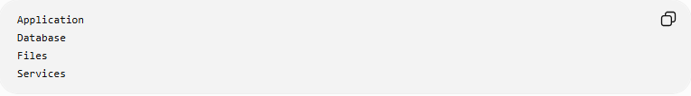
Application
Database
Files
Services

Cloud Database Migration
Database Only

🛠️ Common Cloud Migration Tools
# Source: AI Source: Provided by: [Data Path: Persons Table -> ID Column: 1, Name_En Column: Motasem Essam] -> From: [ChatGPT] on [6/7/2026]
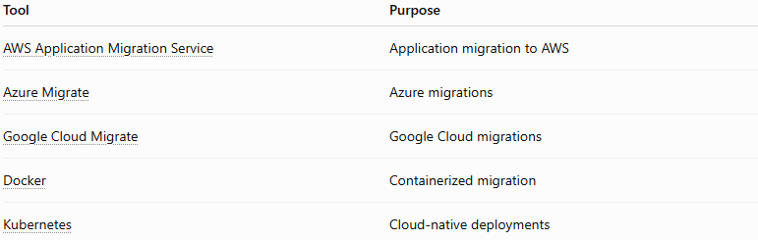
Tool | Purpose
AWS Application Migration Service | Application migration to AWS
Azure Migrate | Azure migrations
Google Cloud Migrate | Google Cloud migrations
Docker | Containerized migration
Kubernetes | Cloud-native deployments

🧠 Simple Analogy
# Source: AI Source: Provided by: [Data Path: Persons Table -> ID Column: 1, Name_En Column: Motasem Essam] -> From: [ChatGPT] on [6/7/2026]
Imagine moving a business office.
Before
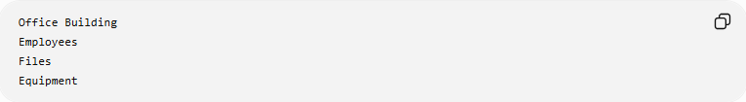
Office Building
Employees
Files
Equipment

Migration
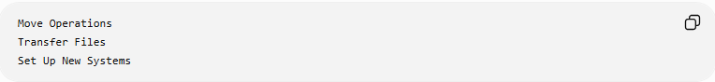
Move Operations
Transfer Files
Set Up New Systems

After
Modern Business Center
The business remains the same, but it operates from a more scalable and efficient location.
Cloud application migration works similarly:
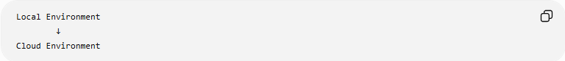
Local Environment
↓
Cloud Environment
while preserving application functionality.

🧭 Summary
# Source: AI Source: Provided by: [Data Path: Persons Table -> ID Column: 1, Name_En Column: Motasem Essam] -> From: [ChatGPT] on [6/7/2026]
Cloud Application Migration is a type of application migration that moves software applications from on-premises servers or data centers to cloud platforms. It may involve migrating application code, databases, files, APIs, and infrastructure. Common approaches include on-premises to cloud, cloud-to-cloud, and hybrid cloud migrations, often using strategies such as Rehost, Replatform, and Refactor. The primary benefits are scalability, high availability, disaster recovery, reduced maintenance, and improved global accessibility.

